System Design Document

Cardzo
-
Document Tools
& EBookReader

Submitted By

Sidarth CS
Praveen Kumar T Krishnendu Suresh
Jyothis KS
Jabirhusain KP

On

10 - October - 2020

Table Of Contents

1. Introduction
1. Purpose
2. Scope
3. Overview

2. System Overview

3. Design Considerations
1. Goals
2. Development Methods

4. System Design
1. Use Case Diagram
2. Data Flow Diagram
3. Transition Diagram

5. Graphical User Interface Design
1. Overview
2. GUI Models

1. INTRODUCTION

1.1. Purpose
This purpose of this document is to outline in detail the system
design of Cardzo - Documents App. This document will provide the use case diagram, data flow diagram,state transition diagram and table design of Cardzo to give a better understanding of how information will be processed with regards to the application. In addition, images will be provided that show the GUI model to give a better idea of the system's user interface design.

1.2. Scope
This document provides the design of Cardzo. It will show how the
application's functionalities work by explaining each of the system's components.

1.3. Overview
This document will cover the basic functionality of the application,
its context and its design. It will cover how data flows within and out of the system. The system architecture will cover each of the components of the application and its relation to system functionality.

2. System Overview

The Cardzo app will give the user pretty much every features regarding managing documents like converting, creating, viewing documents along with an epub reader to make it easy to read books from our smartphone device. Our app mostly works on offline to ensure that the privacy and security of user and user’s documents. Even if there is some features requires to make use of our servers no files stored on server.

3. Design Considerations
3.1. Goals
• Ease of usability is top priority for the development process.
• The application will have buttons with labels that explain the

functionality of that button.

- Making more features available in one app

3.2. Development Methods
This project was initially conducted using the waterfall model
method. As time progressed we switched to incremental model due to new features addition and modification of existing features.

4. System Design

4.1 Use Case Diagram

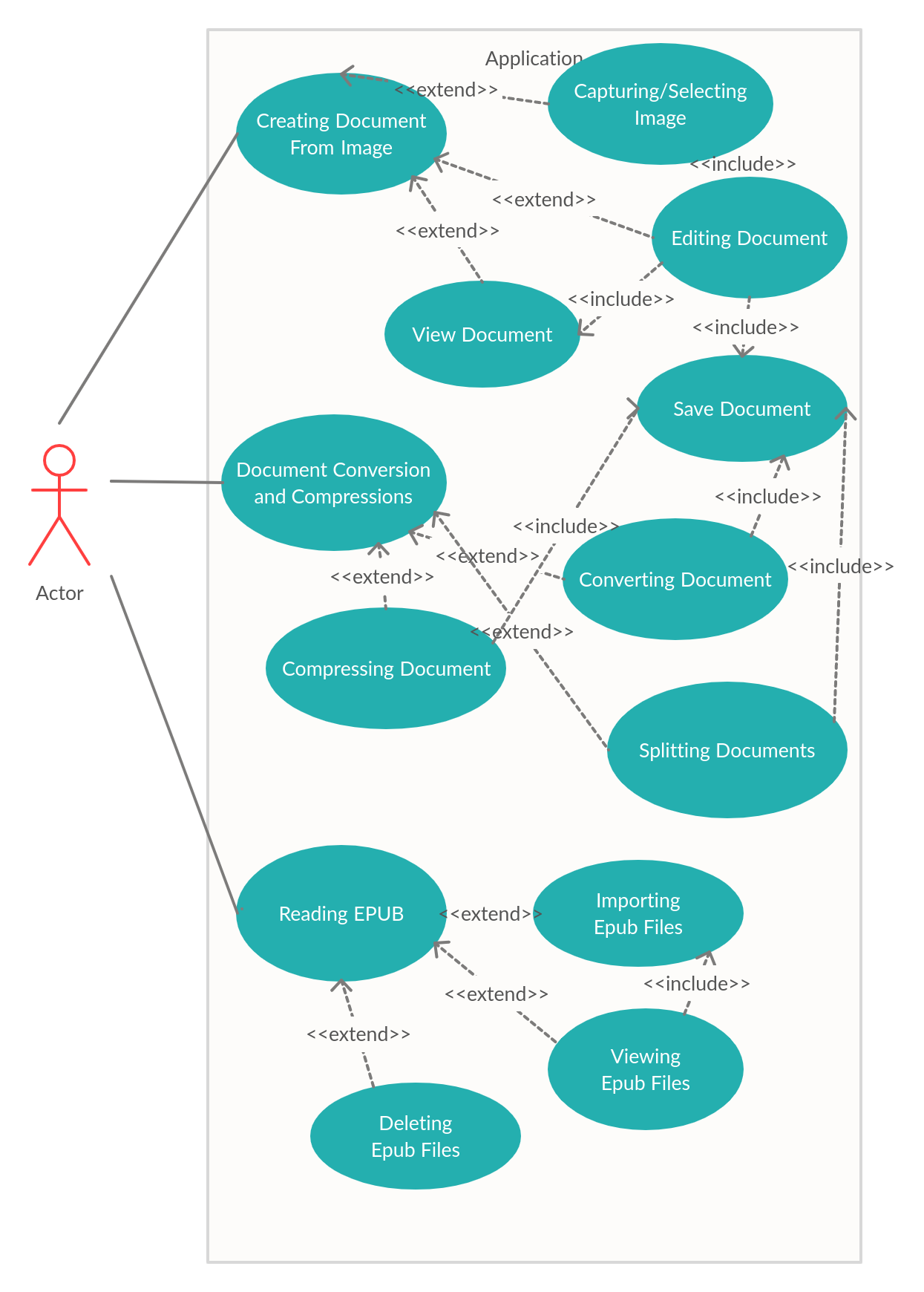

4.2 Data Flow Diagrams

Application Data Flow Diagram

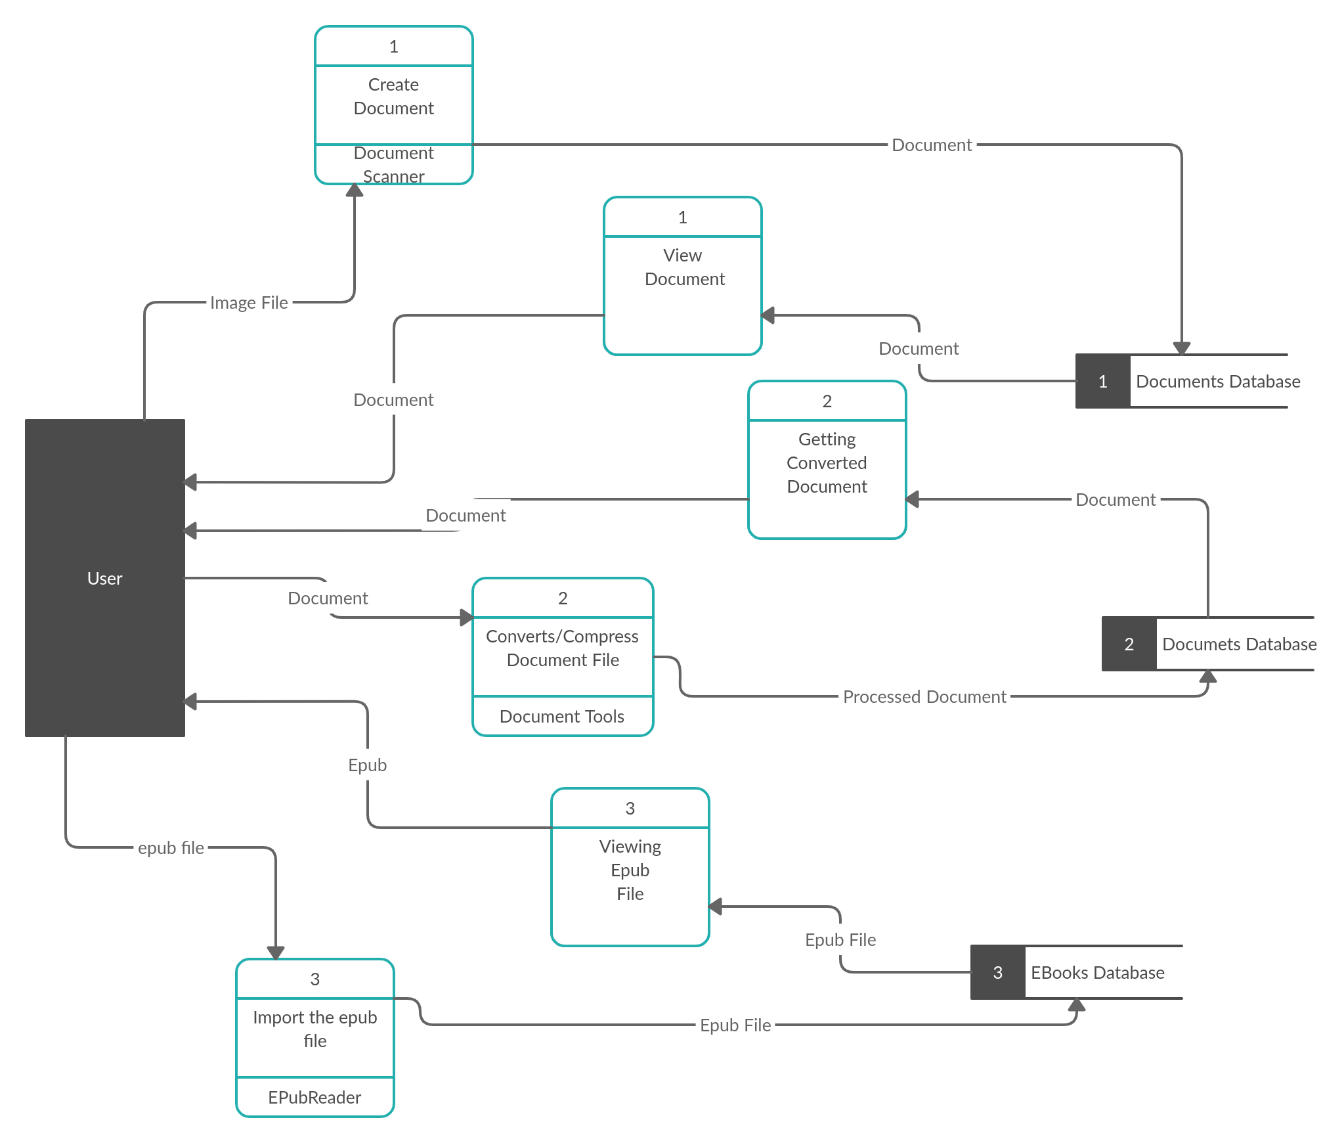

Document Scanner Module Data Flow Diagram

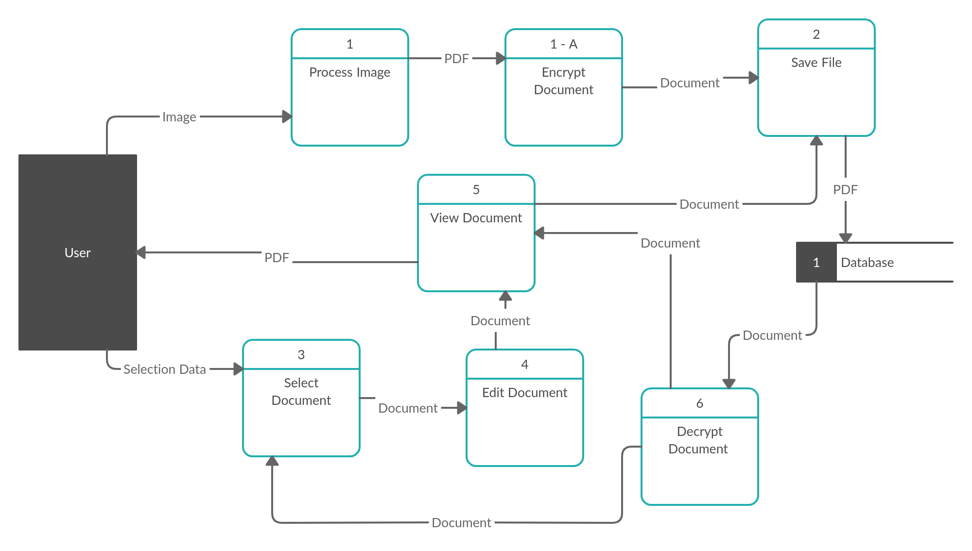

Document Tools Module Dataflow Diagram

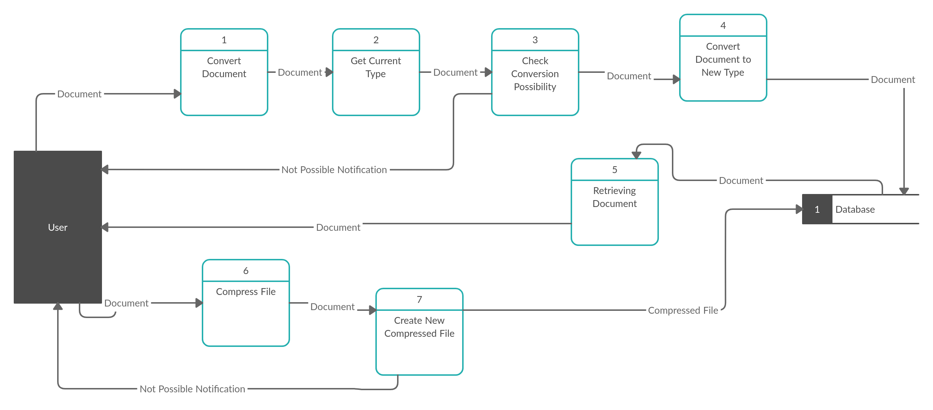

Ebook Reader Module Data Flow Diagram

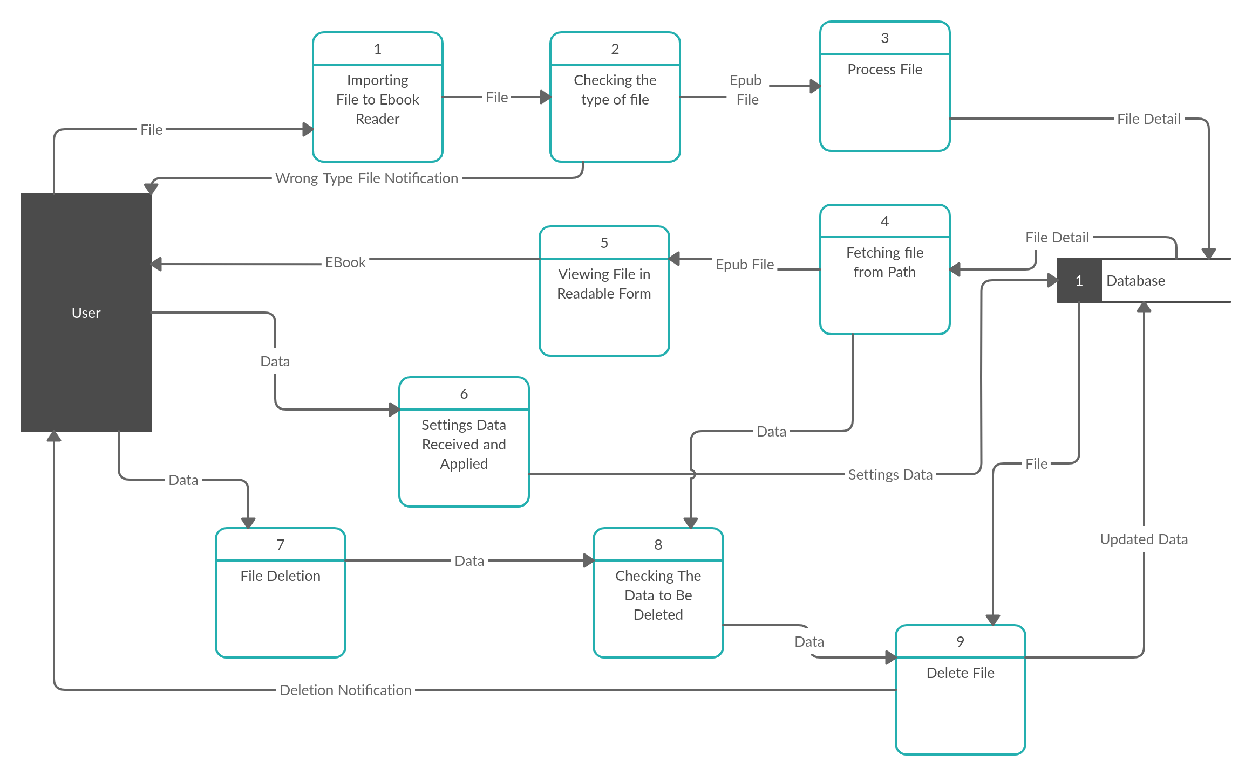

4.3 Transition Diagram

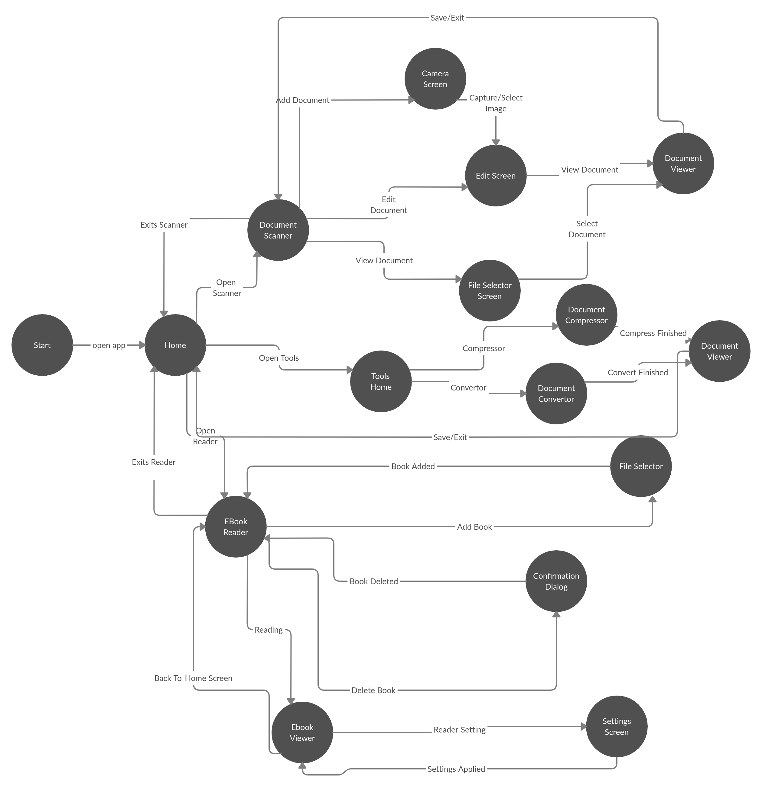

5. Graphical User Interface

5.2 GUI Models

Document Scanner Home

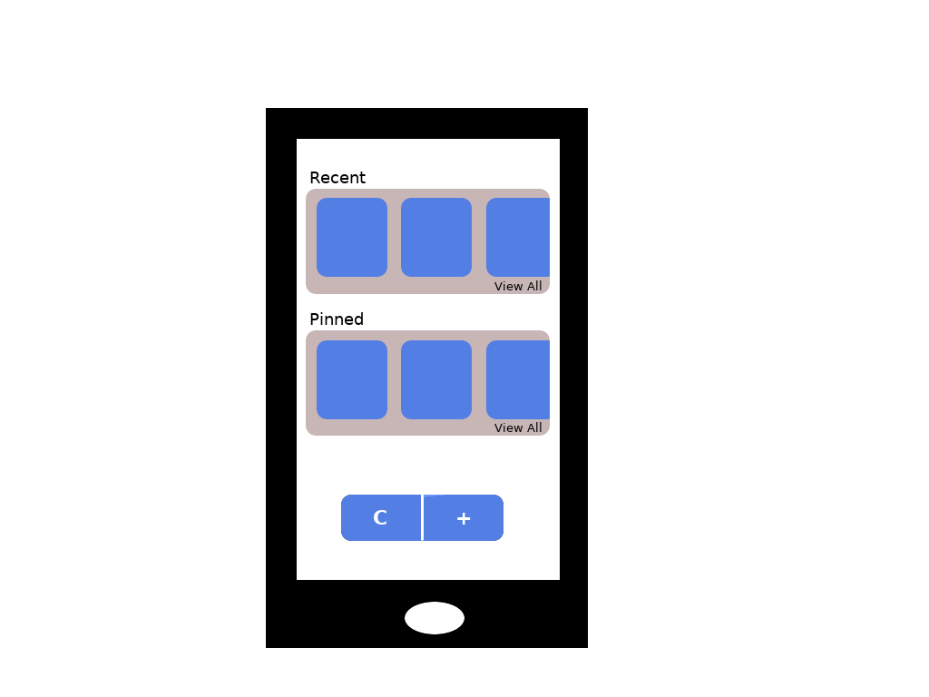

Document Scanner

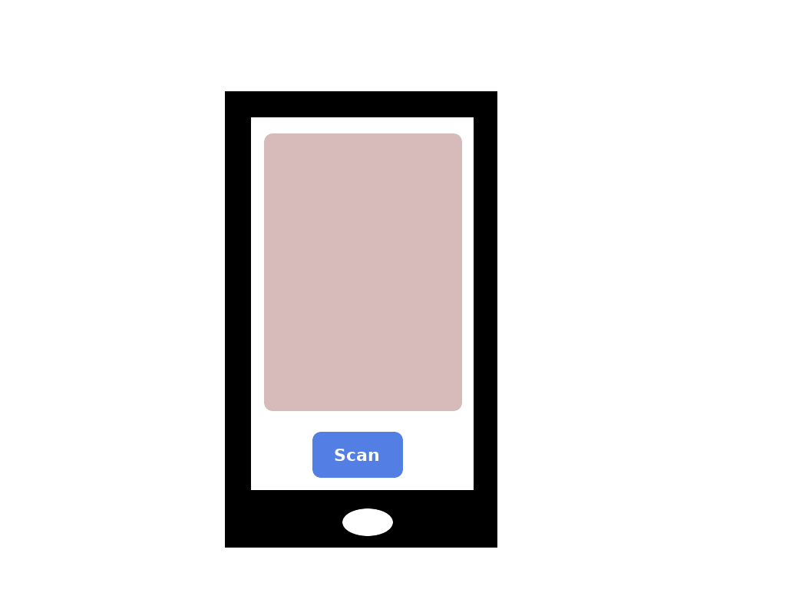

Viewer

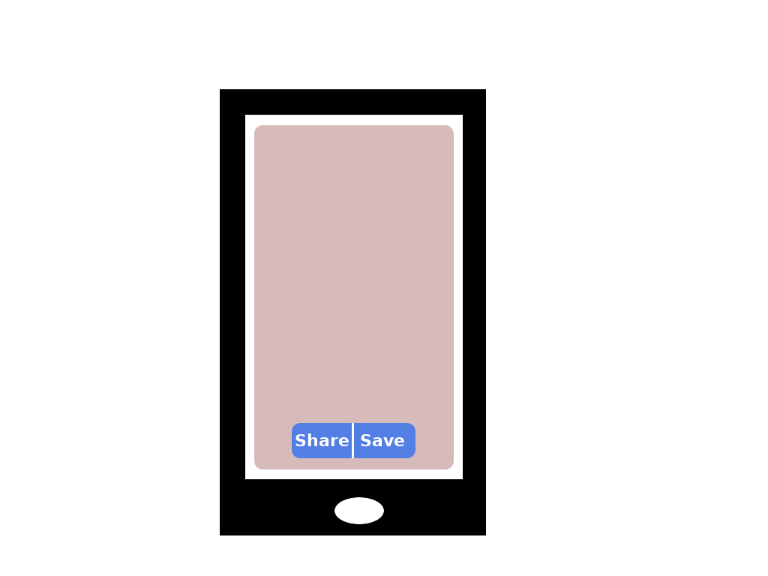

Document Selection Screen
